*background, problem statement, methodology, results, conclusions, and any supporting documentation.*

**Introduction**:

This project centres on developing a Handwriting Recognition System, a technology that converts handwritten text into digital format. With applications in document digitization, data entry, and beyond, the system aims to bridge analogue and digital interactions. Combining expertise from computer science, machine learning, and image processing, the project addresses the challenge of accurately deciphering diverse handwriting styles, contributing to the evolution of seamless human-computer interaction.

**Problem Statement:**

In addition to addressing the shortcomings of conventional human data entry procedures, this initiative attempts to close the gap between handwritten and digital data. The objective is to design a Handwriting Recognition System that blends the familiarity of human input with the benefits of digital data management, to improve productivity across several areas. This system aims to provide consumers with the best of both worlds by delivering an easy-to-use and effective way to process and transcribe handwritten text.

**Methodology:**

Transformer-based Optical Character Recognition, or TrOCR, uses transformer designs for handwriting recognition. These structures are commonly utilized in natural language processing activities including text production and language translation. The following is a development process for a handwriting recognition system based on TrOCR:

**Data collection:** Compile a sizable dataset of handwritten samples using a variety of writing instruments, languages, and styles. Images of handwritten text with labels ought to be included in the dataset.

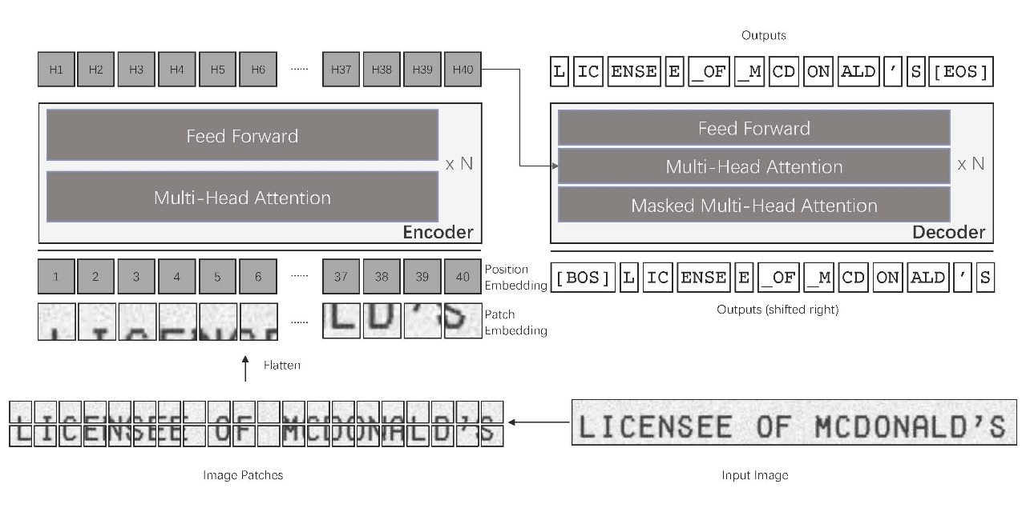

**Data Preprocessing**: Make the pictures uniform: To guarantee that the input dimensions are constant, resize, crop, and normalize the photos.

Transformations such as rotation, scaling, and noise addition can be added to the dataset to improve the robustness of the model.

Text from images can be extracted using Optical Character Recognition (OCR) techniques, which also produce ground truth labels for training.

**Architecture Model:** Architecture of Transformers: Make use of transformer-based architectures such as GPT, BERT, or their combinations. Transformers are useful for sequence-to-sequence applications such as handwriting recognition because they are good at capturing long-range dependencies.

**Adjustment for Picture Inputs:** Redesign the transformer architecture to support inputs of images. Convolutional layers can be used as the first feature extractor to process the pictures before sending them into the transformer layers to do this.

**Positional Encoding:** Add positional encodings to the transformers to provide spatial information about the handwritten text, as transformers do not naturally include positional information.

**Loss Function:** To train the model, use sequence-to-sequence loss functions such as sequence cross-entropy loss or Connectionist Temporal Classification (CTC) loss.

**Optimizer:** Transformer-based model training typically uses the Adam optimizer with learning rate scheduling.

**Fine-tuning**: To improve performance, pretrain the model using sizable text corpora (if available) and then fine-tune it using the handwritten dataset.

**Metrics:** Use metrics such as accuracy, precision, recall, and F1-score to assess the model's performance.

**Cross-validation:** To evaluate the model's capacity for generalization, do cross-validation.

**Post-Processing:** Language Model Integration: Optionally, integrate a language model to improve recognition accuracy by considering contextual information.

Error Correction: Implement post-processing techniques like spell-checking and grammar correction to refine the output text.

**Results:** 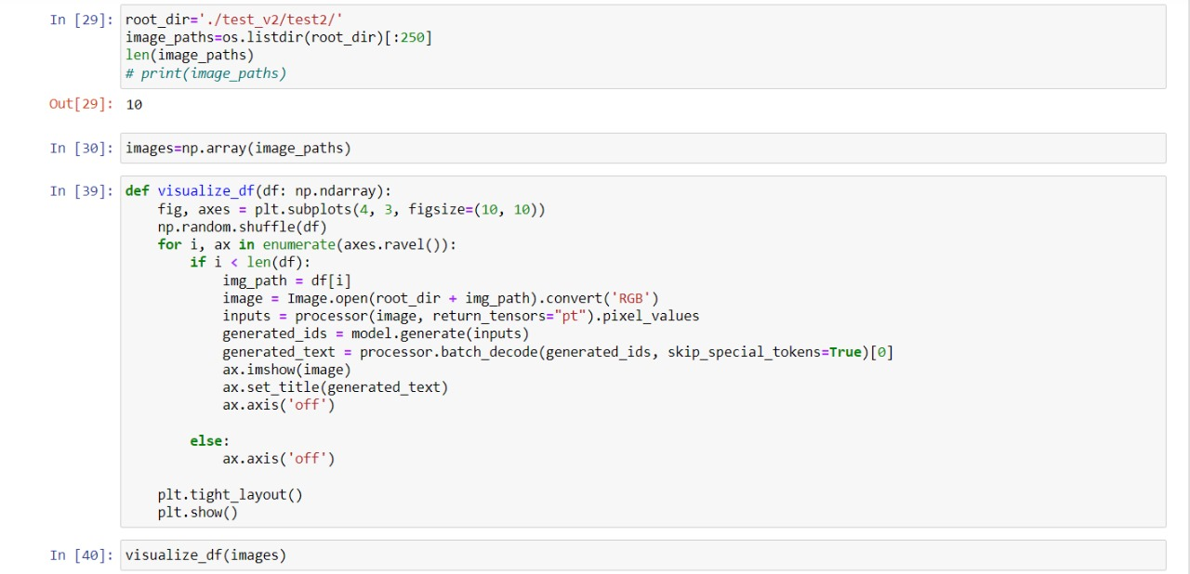

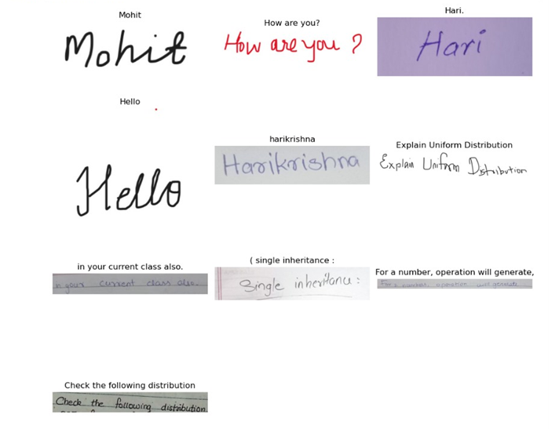

**Conclusion:**

In brief, our project sets out to craft a reliable system for recognizing handwritten text, embracing diverse styles and scripts. Through careful data collection, model training, and user-friendly interface development, we aim to break down barriers between handwritten and digital realms. With a dash of student innovation, dedication, and a sprinkle of campus collaboration, we're striving to deliver a solution that's not only accurate but also accessible and fun to use.

Overall, our solution offers a user-friendly interface and seamless integration with everyday tasks, making handwritten text recognition accessible and convenient for everyone.